Vector Based Drawing Application

Name : Islam Mohamed Mohamed Ibrahem

ID: 12

Name: Bahaa Khalaf

ID: 2

2019

Hp

12_21 Team

11/5/2019

Vector Based Drawing Application

Name : Islam Mohamed Mohamed Ibrahem

ID: 12

Name: Bahaa Khalaf

ID: 2

UML Diagram :

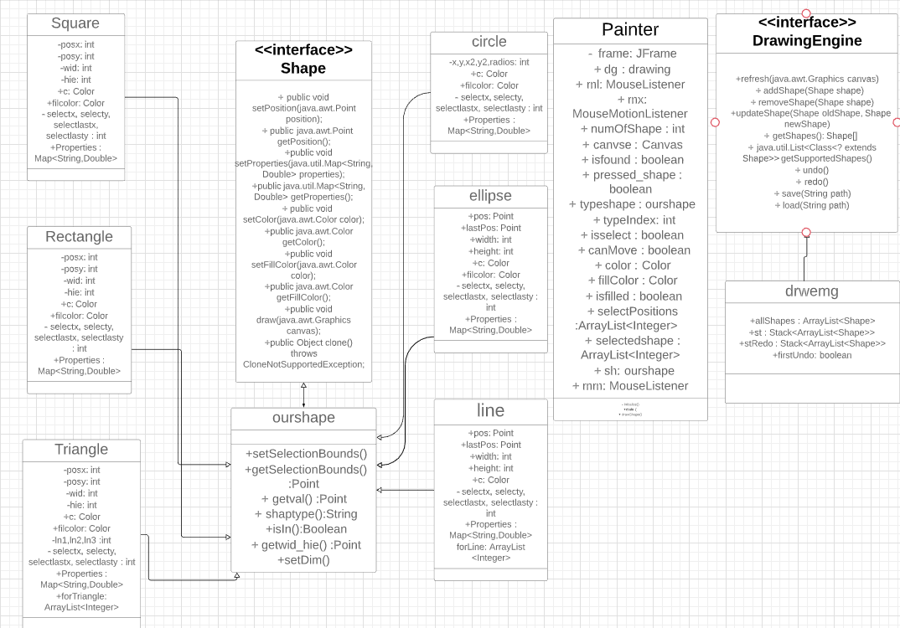

Design Description :

Class Painter :   
-In this class contains Frame and Canvas and Our GUI .  
-For Every shape There is Button to draw It .

-We Add MouseEventListner And Mouse Motion Listiner To Control The Mouse Drawing.

How To Draw ?

When He Press On The Canvas We Take The Position ,

And When He Drag We Took The Dragged Position , And Repaint The Canvas And By Using refresh() We Draw All Shapes Again Until He Released Mouse , When He Release Mouse We Take The Last Position And By Using draw() We Draw The Shape And We Use addShape() We Store This Shape In ArrayList Of Shapes (allShapes)

How To Select Shape ?

We Use MouseListner To Know When He Pressed On The Canvas.

* When You Click At Any Point On The Canvas We Check if This Position On The Range Of Any Shape By Using isIn() And If It True (On the Range Of Shape “Inside The Shape” ) We Surround The Shape with Tiny Squares Which Display That It’s Selected

We Save The Selected Shapes To Use It When Move The Shapes , Resize And Remove.

How To Move Shape ?

By Using A Flag isselect We Check If Any Shape Is Selected And

By Using MouseMotionListner(Mouse Dragged) We Reset The Position Of The Shape , And We Repaint The Shapes Every Time The Shape is Dragged.

How To Remove ?

We Use Button To Remove The Shape.

By Clicking On Button We Check If Any Shape Is Selected ,

And Remove It From ArrayList Of Shapes (allShapes)

And We Repaint() Again And Use refresh() .

How To Resize ?

We Use Button To Resize The Shape.

By Clicking On Button We Check If Any Shape Is Selected,

First When The Curser Of Mouse Focused On Any Edge Of Shape The Cursor is Changed To The Resize shape By Using Resize Function

Second When He pressed On Any edge Of The Shape We Reset The Points Of The Shape By using Mouse Drag

Undo & Redo

We Use Two Stacks Of ArrayList Of Shapes (Stack<ArrayList<Shape>>) One For Undo And Other For Redo .

When He Draw Or Move Or Remove A Shape We Store allShapes (ArrayList<Shape>) On the Stack And Clear Undo Stack

When He Pressed On The Undo Button , We Clear The ArrayList Of Shapes (allShapes) , And We Pop The Top Of Stack And Put It On RedoStack And Add It To AllShapes Again

On Pressing Redo Button We Check If He Pressed Undo Before And If It True We Clear All Shapes And Pop The Top And Put It on UndoStack and Allshapes.

Save And Load

XML :

Saving

We Take The Path From The User In The Place That He Want To Save In It.

By Using XMLEncoder encoder.writeObject() We Save The ArrayList Of AllShapes On XML File.

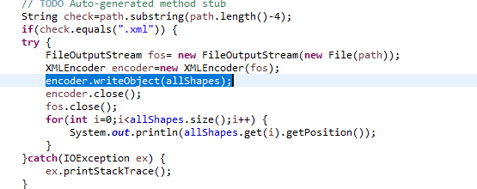

Loading

We Take The Path From The User Where He Saved The XML File , By Using XMLDecoder We Turn The Object That Stored In The XML File To ArrayList Of Shape And Stored it on allShapes

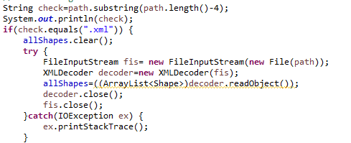

JSON :

Saving : We Looping Over ArrayList Of Shapes (allShapes) And We Turn The Properties And Colors And setSelectedBounds To String On The JSON Form , And Make New JSON File In The Path That We Took From User .

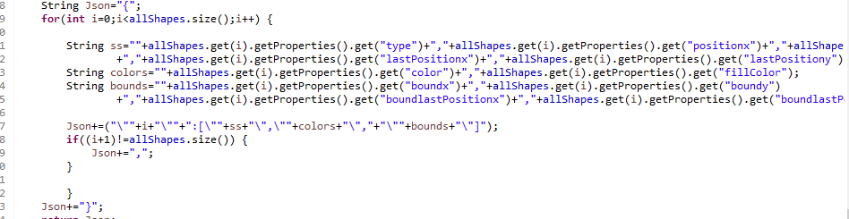

Loading : We Take The path From User Where He Save JSON File ,

We Took The String From The File And Split it To Numbers We Store Numbers In Properties HashMap , In this Properties We Save A Number For Every Shape And Using If Statement We Select The Type of Shape And Make New Object from it And Add it

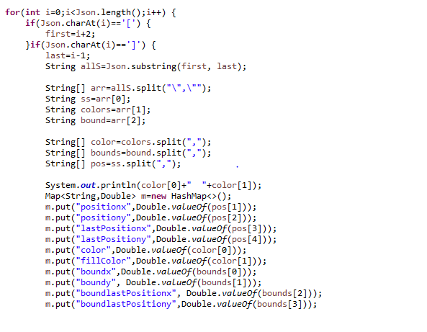

USER GUIDE

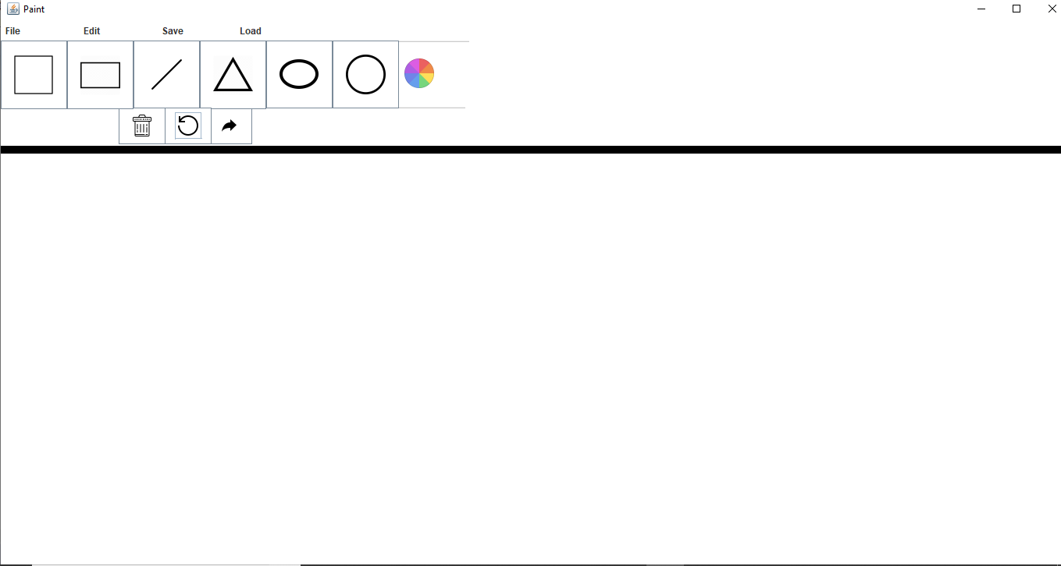

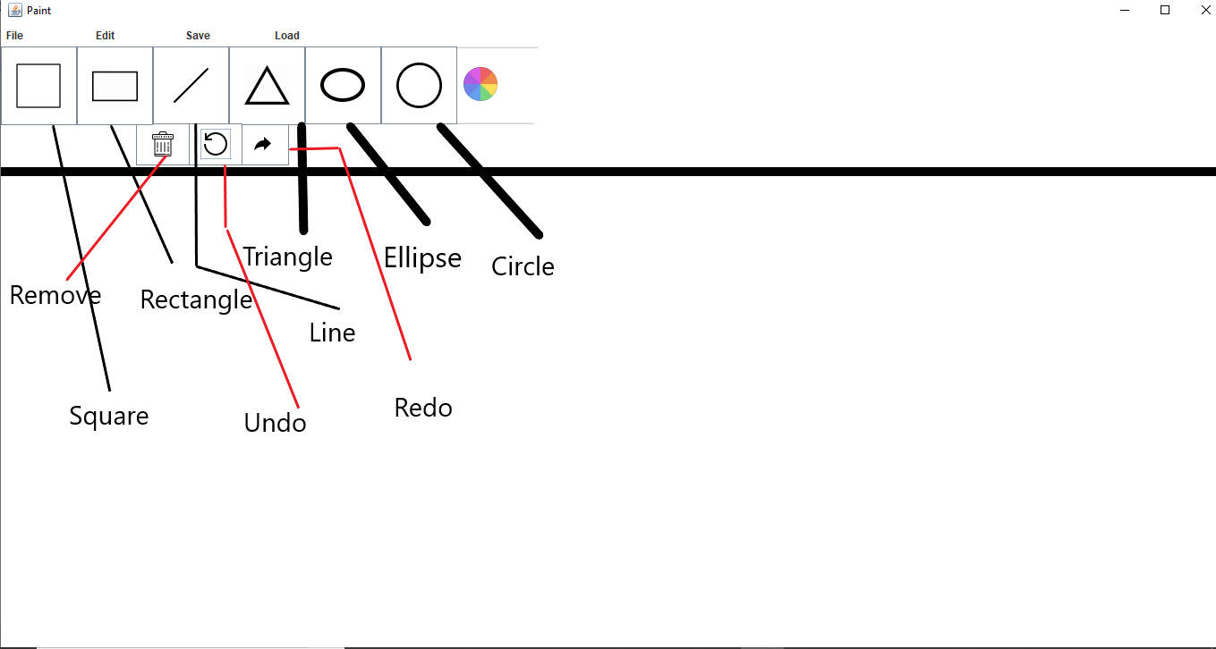

To Save => Choose The Path , And Create File Name With (.xml) Or (.json)

If The User didn’t Put The Right Path The Program Won’t Save.

For Example: Saving As JSON

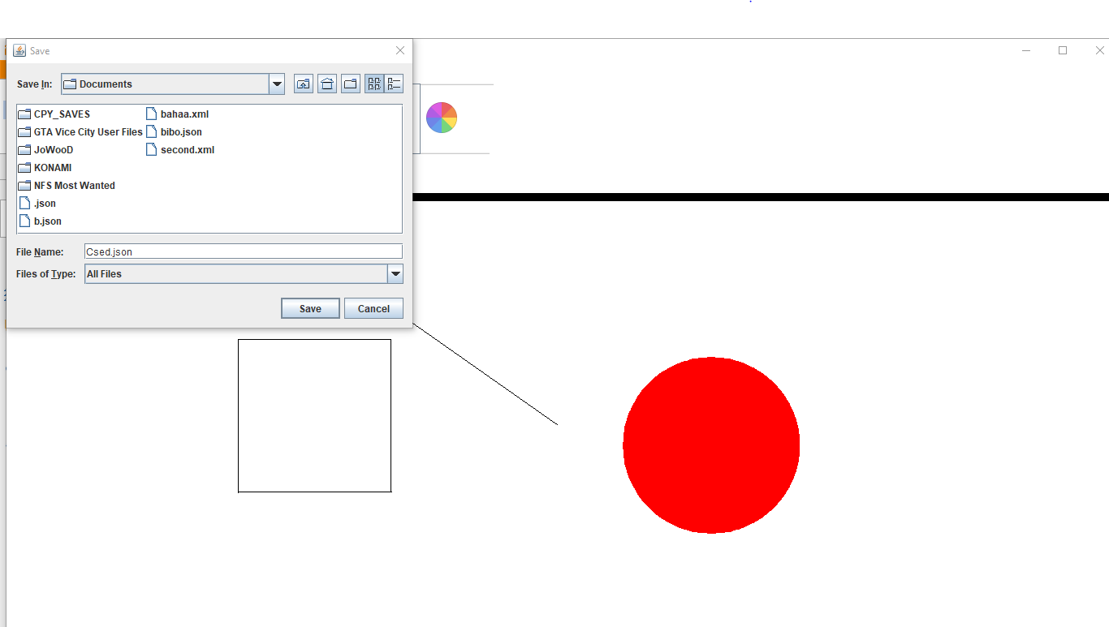

When We Load

Make Sure To Choose A Json File Or Xml File

